Practical No 3
Aim: Using Packet Tracer, create a basic network of one server and two computers using appropriate network wire. Use Dynamic IP address allocation and show connectivity

Theory:
For assigning ip addresses dynamically we use the DHCP protocol
Dynamic Host Configuration Protocol (DHCP) is a client/server protocol that automatically provides an Internet Protocol (IP) host with its IP address and other related configuration information such as the subnet mask and default gateway.
The DHCP server maintains a pool of IP addresses and leases an address to any DHCP-enabled client when it starts up on the network. Because the IP addresses are dynamic (leased) rather than static (permanently assigned), addresses no longer in use are automatically returned to the pool for reallocation.
DHCP provides the following benefits.
- Reliable IP address configuration. DHCP minimizes configuration errors caused by manual IP address configuration, such as typographical errors, or address conflicts caused by the assignment of an IP address to more than one computer at the same time.
- Reduced network administration. DHCP includes the following features to reduce network administration
DHCP runs at the application layer of the Transmission Control Protocol/IP (TCP/IP) stack to dynamically assign IP addresses to DHCP clients and to allocate TCP/IP configuration information to DHCP clients. This includes subnet mask information, default gateway IP addresses and domain name system (DNS) addresses.

We use the following topology for the present case

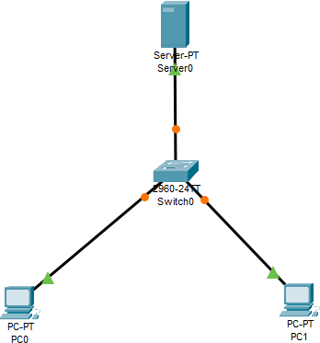

Configuring the Server:
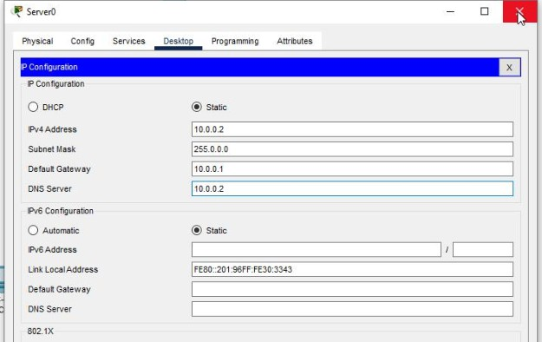

Enabling and setting the DHCP Service on the Server:

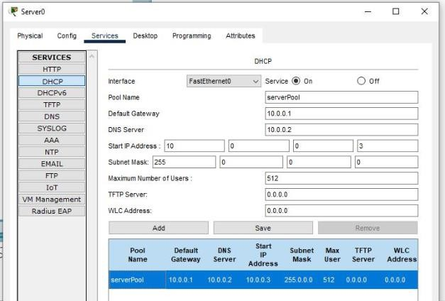

Verifying the Dynamic Addressing on both the PCs:

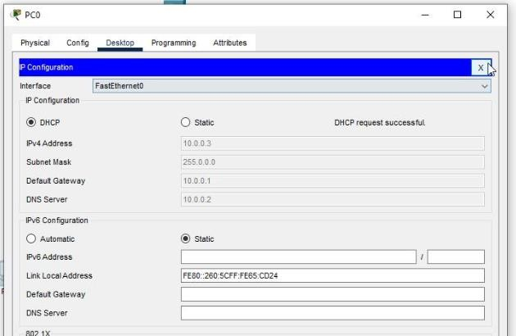

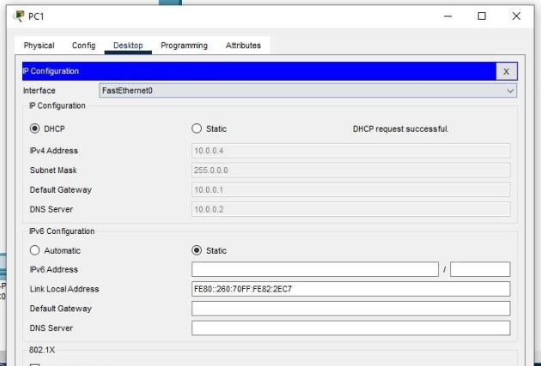
Checking the connectivity:
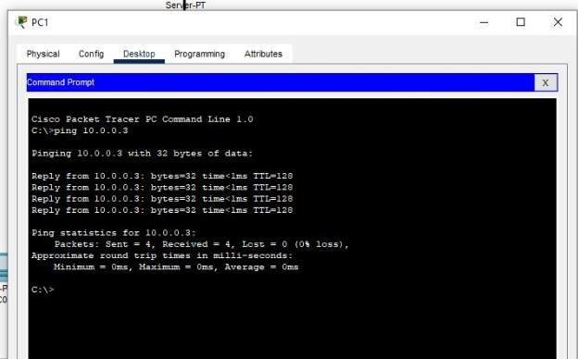

Result:
Hence the Connectivity between the PCs has been verified.

Link for the video demonstration of the practical:
https://youtu.be/Jnj8c_15AiE

